Komisaruk, Zmood, Yovel, Grinblat, Pogorelske – cousin relationships
(Chaim Freedman 18/10/2020)

Tradition held that the Komisaruk, Zmood and Grinblat families, who were interrelated several time, were descended from a common ancestor. The source of this tradition was Maurice (Morry, Meish) Zmood, the son of Harry (Tzvi) Zmood of Melbourne, Australia. During a discussion with Chaim Freedman in the late 1960’s or early 1970’s Chaim commented on the incidence of multiple cousin or inter-family relationships between the above families,.

Maurice’s mother was Bessie Grinblat and her brother Shmuel-Yitskhak (Sam) Grinblat) was the husband of Maurice’s aunt Sheindel (Sophie) Zmood.

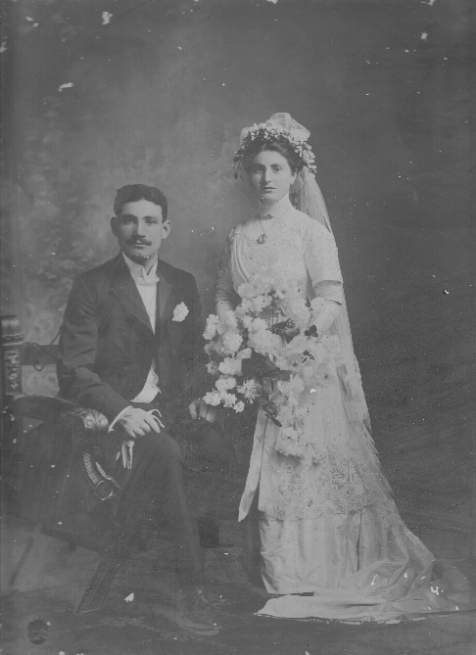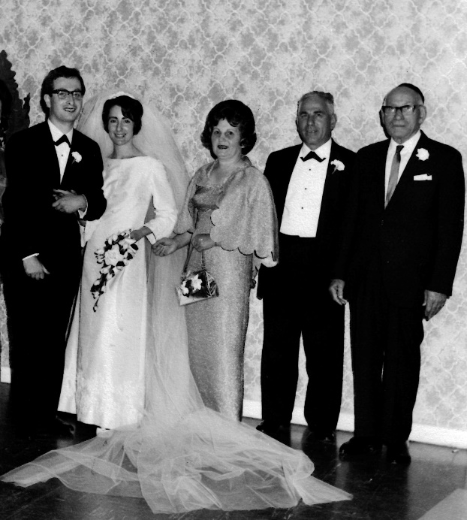
Harry and Bessie Zmood, Wedding of Ron and Devorah Zmood
Melbourne 1911 Bertha, Maurice, Harry. 1966 Melbourne

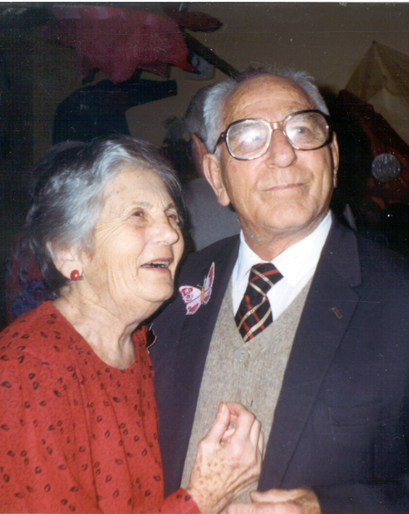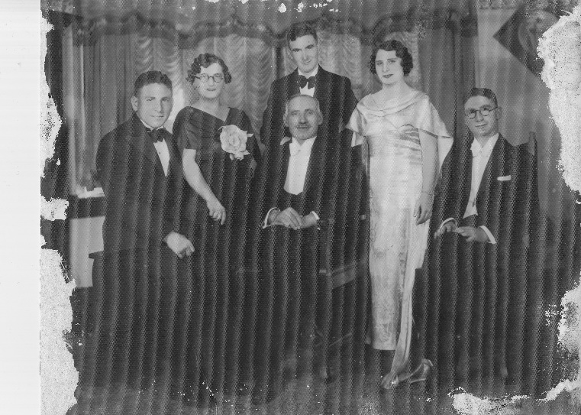
Morry and Bertha Zmood, Raymond Zmood’s wedding, Melbourne 1936
Melbourne c.1990

Harry Zmood’s father Moshe Zmood was a brother to Tybel the wife of Meir Komisaruk.

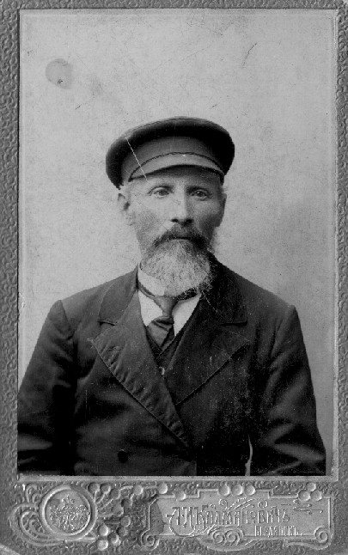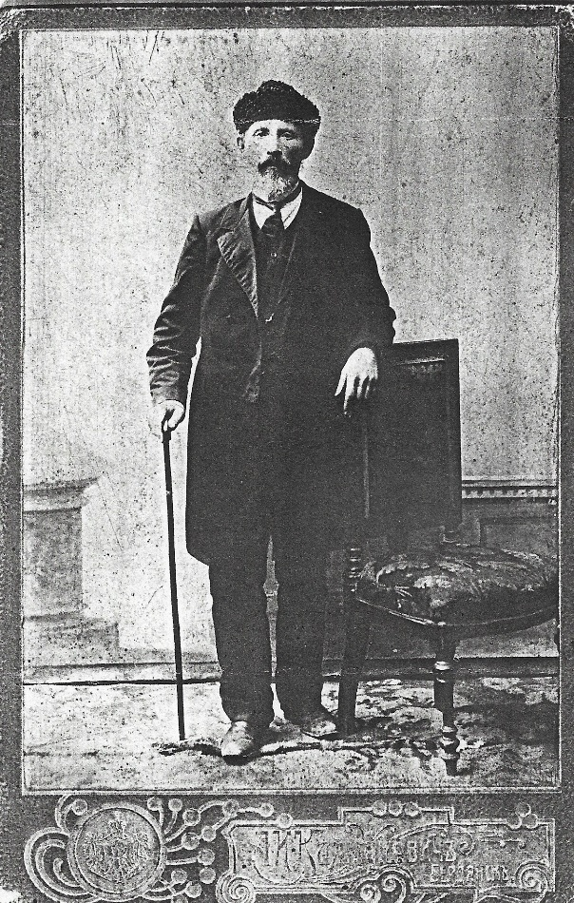
Moshe Zmood, died 1915 Berdyansk, Ukraine

Meir’s brother Menakhem-Mendel was the father of Shlomo-Zalman whose wife Chanah-Reizel was a daughter of his uncle Meir Komisaruk.

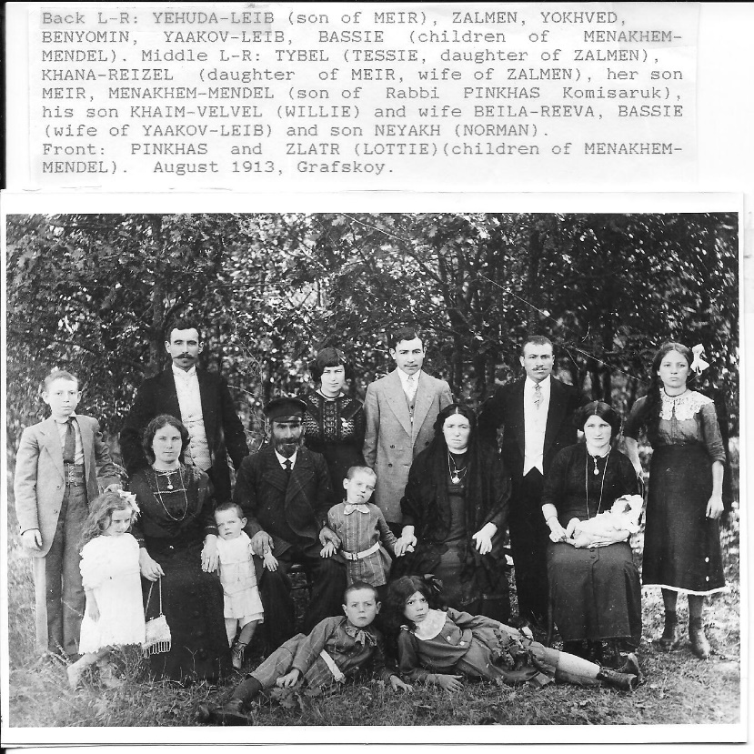

Chanah-Reizel’s sister Tsiporah was married to David Zmood, son of Moshe and brother of Harry and Sophie.
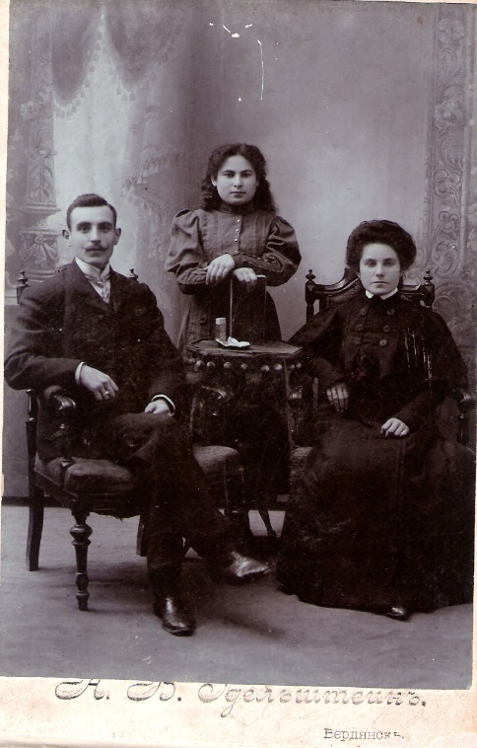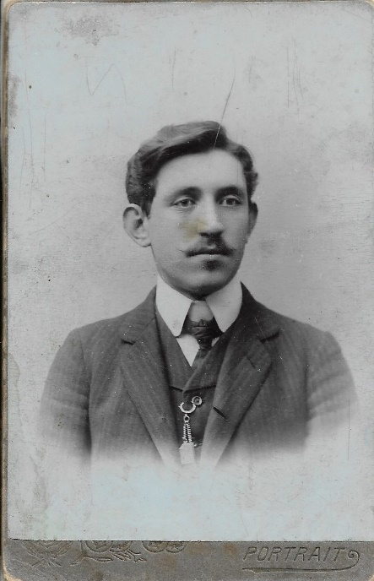
Zalman, Tsipora and Chana-Reizel Komisaruk David Zmood, Ukraine
Berdyansk, Ukraine c. 1908

Chanah-Reizel’s youngest sister Chayalah was married to Moshe Kogan as son of Reizel Kogan, a half-sister to Meir and Mendel Komisaruk. Reizel’s daughter Bassie was the wife of Mendel Komisaruk’s son Benyamin Komisaruk.

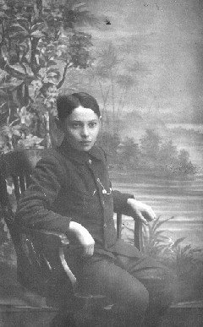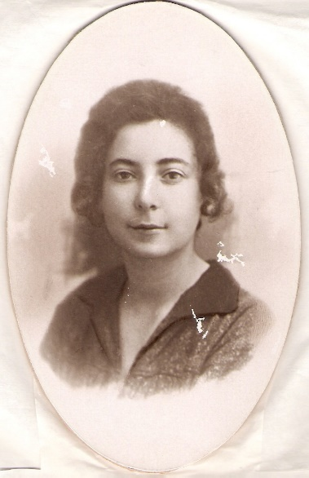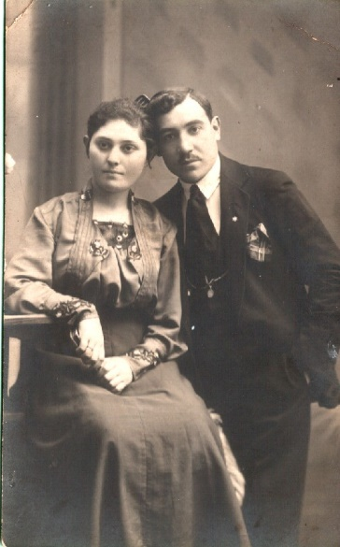
Moshe Kogan, Yuzovka his wife Chayala Komisaruk Bassie Kogan and Benyamin
(Donetsk) c.1913 Yuzovka c. 1925 Komisaruk, c.1914 Ukraine

Meir and Mendel’s sister Dina Namakshtansky was the mother of Chaim whose wife Chaya-Rochel was a daughter of Meir and Mendel’s eldest brother Rabbi Shlomo-Zalman (of Vasilkovka) , the eldest son of Rabbi Pinchas Komisaruk and not to be confused with his namesake Rabbi Shlomo-Zalman Komisaruk of Raseiniai and Grafskoy, the father of Rabbi Pinchas Komisaruk.

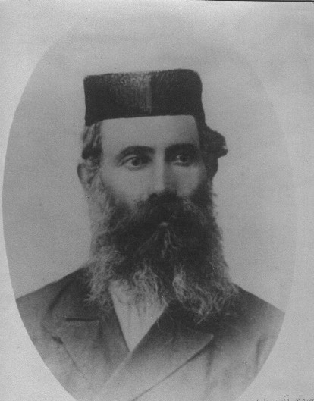
Rabbi Shlomo-Zalman son of Rabbi Pinchas Komisaruk
About 1914, Vasilkovka, Ukraine.
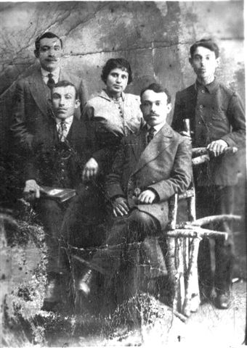
Left to right top row; Benyamin Komisaruk. Rochel Namakshtansky/Berchansky/Luban,
Pinchas Namakshtansky,
Front, Shmilik Namakshtansky, Chaim Namakshtansky. About 1915, Ukraine
All except Rochel and Benyamin were murdered in the pogrom in 1919 in colony Trudoliubovka. Benyamin was murdered in 1919.

Dina Namakshtansky’s daughter Rochel’s husband, by second marriages was Yosef-Dov (Alter) Luban, a son of Ester Luban, sister of Shlomo-Zalman, Dina, Menachem-Mendel and Meir Children of Rabbi Pinchas Komisaruk.

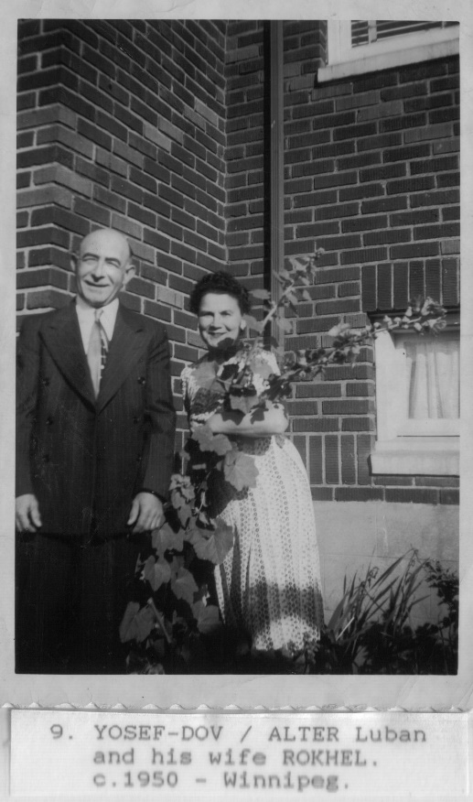

Alter Luban and Rochel, nee Berchansky, nee Namakshtansky
Winnipeg c. 1950

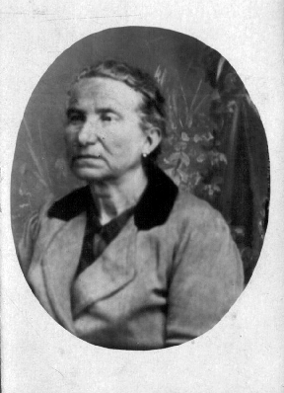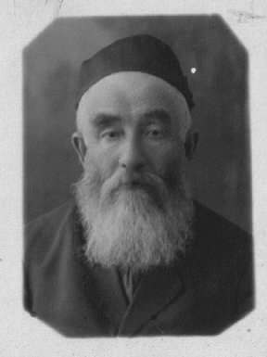
Ester Luban, date and place unknown, her husband Rabbi Chaim-Moshe Luban
Maybe Harbin, Manchuria 1924-1928

Understood?

Clear?

Maybe others?

Yes, the Yovel family.

Moshe Zmood, father of Harry, David and Sophie, was married to Rochel Yovel, daughter of Tzvi Yovel who originated in the Lithuanian town Plungian (Plunge). Tzvi was one of the original settlers in the colony Trudoliubovka (Engels), close to the colony Grafskoy where the Komisaruks settled. The Zmood family originated in the Latvian town Ludza (formerly Lutzin) and settled on the largest colony Novozlatopol. Most of the Zmoods moved in the 1870’s to the village Andreyevka, and the nearby city Berdyansk.

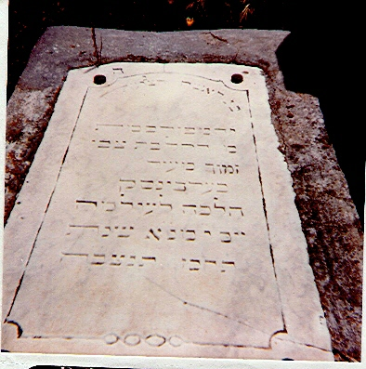
Tombstone of Rochel Zmood, nee Yovel, 1907 Trumpeldor cemetery, Tel Aviv.

Tzvi Yovel’s sons Avraham-Mordechai, Zev-Volf settled in Eretz-Yisrael and Moshe (changed his name to Rabinov) immigrated to Melbourne, Australia where many of his brothers’ children also settled.

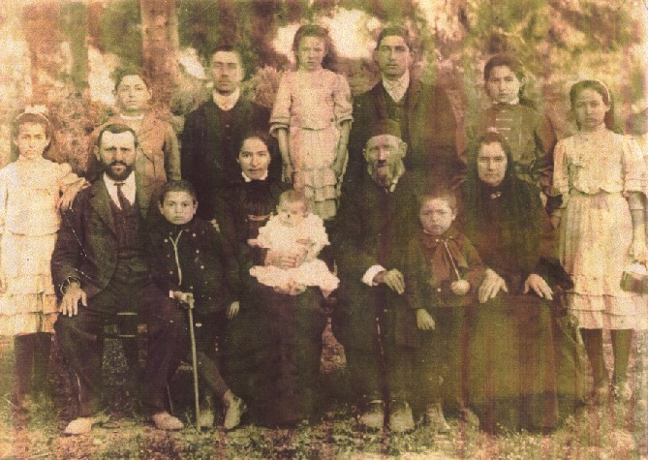
Avraham-Mordechai Yovel and family, Rishon-Letzion, Israel, He died in 1924 in Hadera

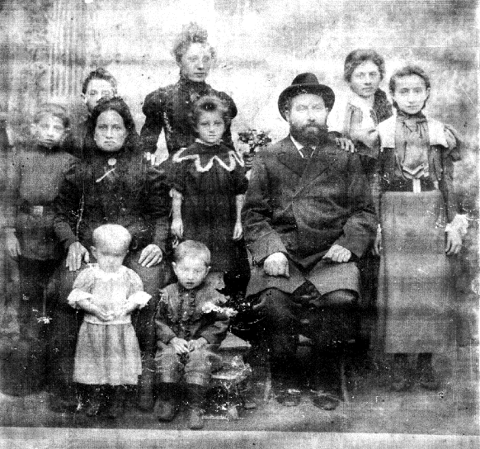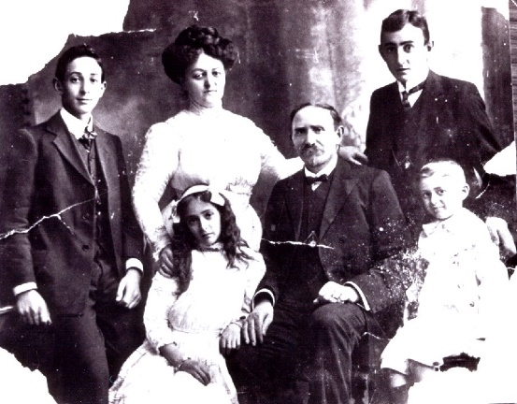
Zev Yovel and family, Berdyansk about Moshe Rabinov (ex Yovel) Melbourne.
1904. He died in Tel Aviv in 1931

Moshe Rabinov was the first member of the Yovel (Joel) family to settle in Australia in 1886. He was followed by his nephews Harry and David Zmood and subsequently by the Komisaruk/Komesaroffs and many other inter-related families and non-related families who came from the same areas of the Russian Ukraine. This migration chain ended in the late 1920’s when Stalin slammed the doors on exits from the Soviet Union.

To add a further complication, Maurice Zmood told Chaim Freedman that his grandparents Moshe Zmood and Rochel Yovel were also cousins, which meant that the Komisaruks descended from Moshe’s sister Tybel Komisaruk were also descended from the Yovels.

Maurice further expanded the puzzle by saying that aside from the interrelationships in his parents’ and grandparents’ days, these families all came from a much earlier common ancestor in Lithuania.

Is this truth, partial truth, or legend?

The Komisaruk family was descended from the Gaon of Vilna through Rabbi Shlomo-Zalman Komisaruk’s mother Ester a daughter of the Gaon’s second son Rabbi Yehudah-Leib of Serhei. An explanation of that relationship is included in Komisaruk database.

Chaim Freedman from his research of the families proposed that the Zmood family was related to the Komisaruk family through a sister of Rabbi Shlomo-Zalman Komisaruk, Chanah-Reizel the wife of David Zmood.

Their son Koppel’s wife Deverah was thought to have been a sister of Tzvi Yovel.

The relationship of the Grinblat family was based on a conversation between Chaim Freedman’s parents and Raymond Grinblat (a son of Sophie Zmood) who was told of descent from a “Gaon” in Lithuania. Given the relationships with the Komisaruk family, it was assumed that the Grinblats were probably descended from a sister of rabbi Shlomo-Zalman Komisaruk.

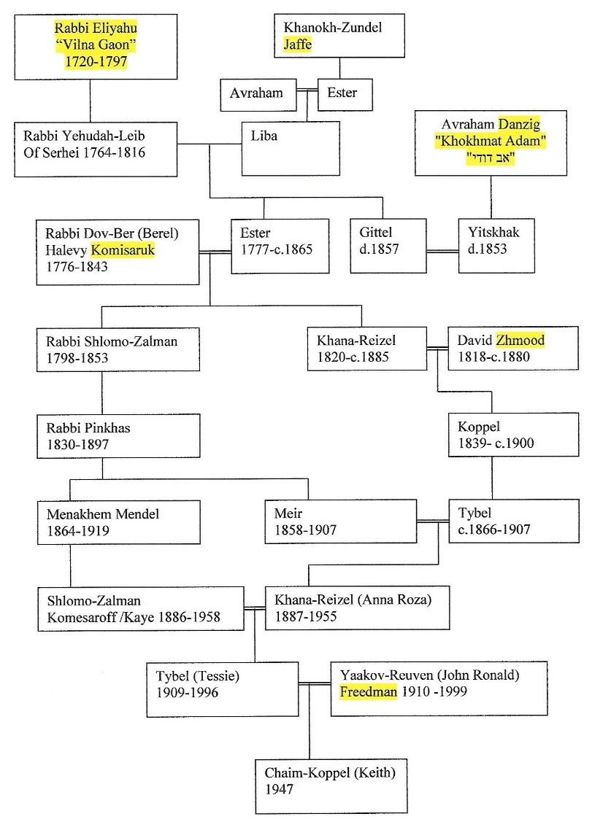

New information was discovered in August 2020 which necessitated rethinking the above relationships.

Michoel Ronn, whose family, like the Komisaruk, Zmood and Yovel families, originated on the Jewish Agricultural Colonies in the Ekaterinslav Province, Mariupol province, South-Eastern Ukraine received copies in 2020 of the entire 1858 census of five of the colonies. Relevant to the above families were the colonies Novozlatopol and Trudoliubovka. Colony Grafskoy which was the home of the Komisaruk family was received in 2002 from the Zaporozhe Archive which was commissioned by Mel Comisarow to search for information about a number of families.

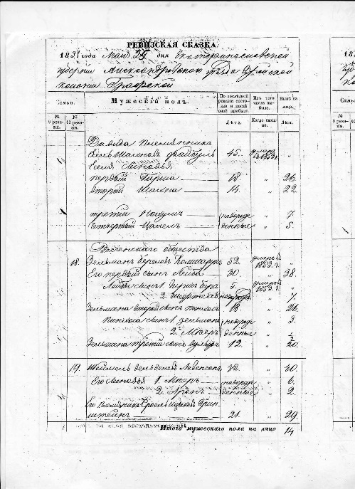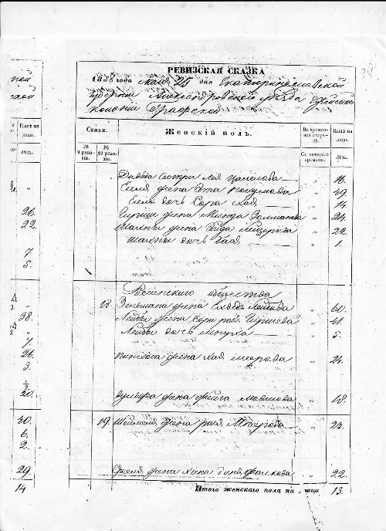

1858 census of Colony Grafskoy from the Zaporozh, Ukraine Archive
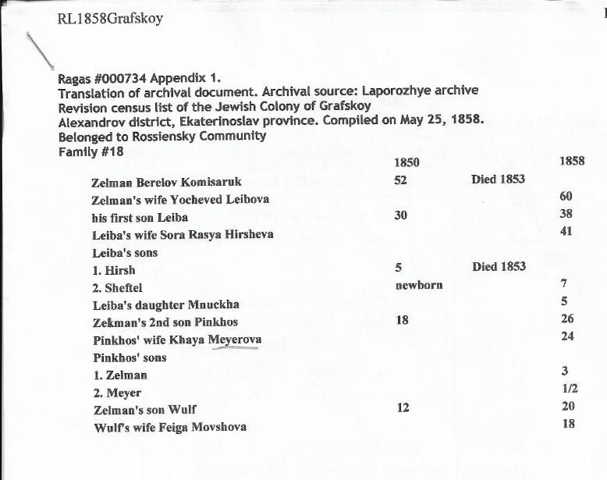

The archive was relied upon to search manually through a large quantity of diverse records, simultaneously for individual details of a number of families. In practice this system was found to be unreliable as entire entries were missed and others were transcribed incompletely, omitting the wives’ father’s names.
When lists were acquired for the entire colony, these omissions were discovered and proved to hold vital information.

List of people who moved from Vitebsk Gubernia to Novozlatopol 1850/1852:

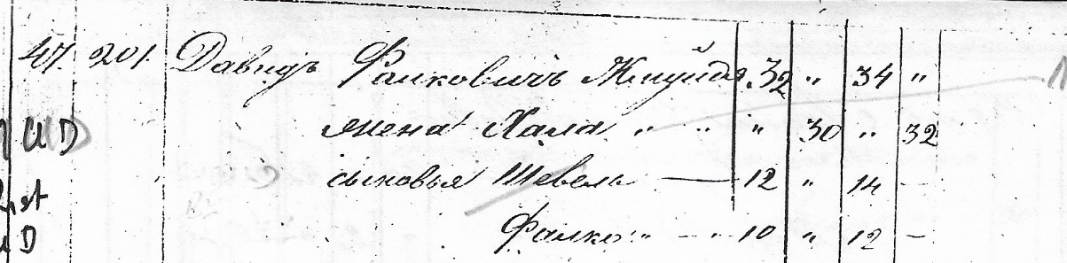
#47
David Falkovich Zhmuydya aged 34 in 1852
His wife Chana 32
son Shevel 14
son Falko 12

The name of the son Shevel is incorrect and should be Kopel.
The name of the father of Chana did not appear.

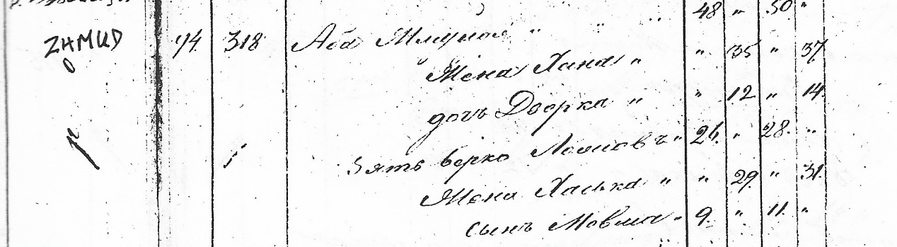
#94
Aba Zhmuydya 50
Wife Chana 37
Daughter Dvorka 14
Son-in-law Berko Lozhov 28
Wife Chaska 31
Son Movsha 11

The name of Aba’s wife’s father did not appear.

When the full list for Novozlatopol in 1858 was acquired, the missing patronymics of the wives appeared.

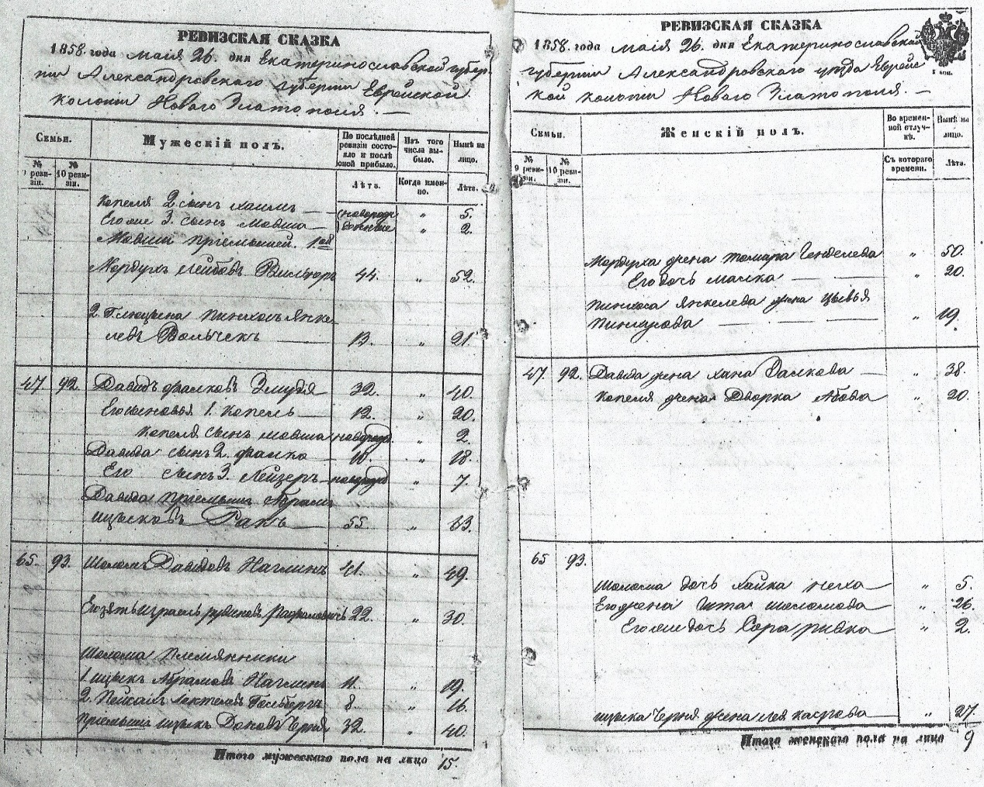

#47 middle entry on page
David Falkovich Zhmuydya aged 40 in 1858
His wife Chana Zalkova 38
son 1.Kopel 20, his wife Dvorka Abova 20
son 2. Falko 18
son 3. Leyzer 7

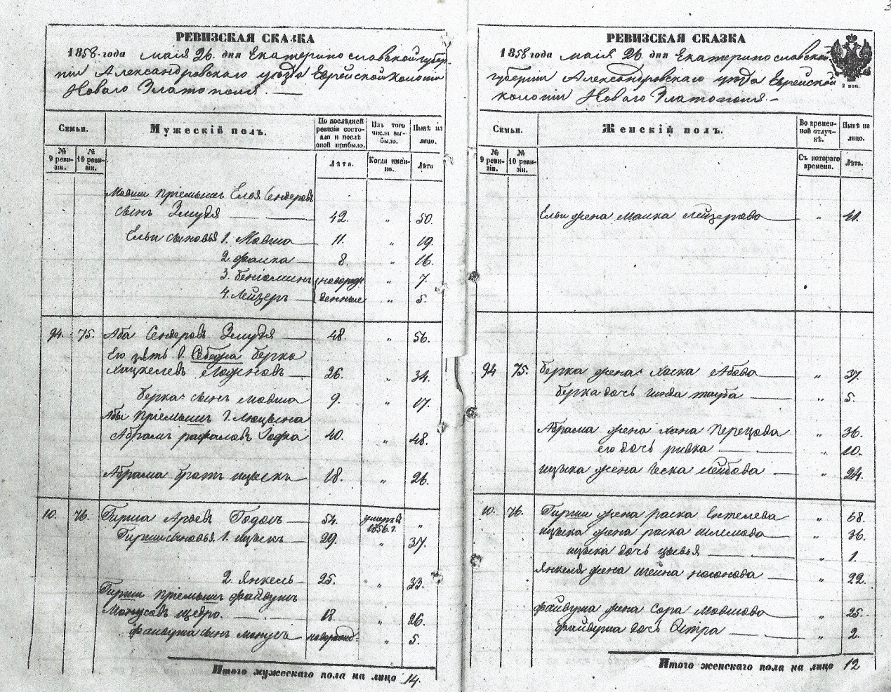

#94 Middle entry on page
Aba Senderov Zmudya 56
Wife Chana and Daughter Dvorka omitted.
Chana may have been deceased.
Dvorka was aged 14 in 1852 so by 1858 she was 20 married and appears in the family of David as the wife of his son Kopel.

The relationship between the Zmood and Komisaruk family was previously thought to be through David Zmood’s Wife Chana, as a sister to Rabbi Shlomo Zalman Komisaruk, even though there was considerable age difference of twenty two years and no known siblings between them.
If Chana was a sister of Shlomo Zalman her father had to be Rabbi Dov Ber/ Berel Komisaruk and her patronymic had to be Chana Berelova.
Buy Chana’s patronymic according to the 1858 list was Zalkova.

Thus it has been shown that Chana was a daughter of Shlomo-Zalman and not his sister.
She was thereby more closely related to the Komisaruk than previously thought to be.
Her full name was Chana-Reizel, after whom was named her great-granddaughter Chana-Reizel Komesaroff/Kaye, the daughter of Meir Komisaruk and Tybel Zmood daughter of Kopel Zmood.

The relationship between the Zmood and Yovel family also requires revision according to the 1858 Novozlatopol and Trudoliubovka 1858 lists.
It had been thought that Dvora (Dveira according to the Lithuanian pronunciation), the wife of Kopel Zmood was a Yovel, sister of Tzvi Yovel whose sons Avraham-Mordechai,
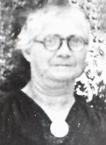
Chana-Reizel Lehrer, Melbourne. Daughter of Moshe Zmood and sister of Harry Zmood.

Zeev and Moshe are mentioned above. But Tzvi, their father, appears in the 1858 list for Trudoliubovka as a son of Marek Yovel, Marek usually was used for the Hebrew name Mordechai.
Yet Dvora’s father was Aba and not Marek/Mordechai.

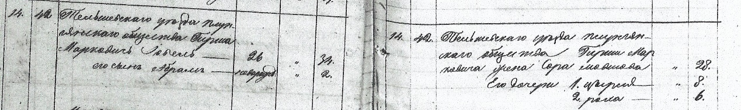
Telsh Uyezd [district]
Plungyansk community
Girsh Markovich Iovel 34
His son Abram 2
Girsh’s wife Sora Moshova 28
His daughter Tzirel 8
Rokha 6

Rokha was the wife of Moshe Zmood, father of Tzvi, father of Maurice Zmood.

.

Theory:

Dvora the wife of Kopel Zmood was the daughter of Aba Zmood whose wife Chana was a daughter of Marek/Mordechai Yovel and a sister to Tzvi Yovel.

This supports Maurice Zmood’s statement that his grandparents Moshe Zmood and Rochel Yovel were cousins, although not first cousins.
Aba Zmood was a son of Aleksander (Sender) Zmood, whose son Falk was the father of David Zmood.

Chana (Chana-Reizel) the wife of David Zmood and mother of Kopel Zmood was a daughter of Shlomo-Zalman Komisaruk and not his sister as previously thought, and thus a sister of Rabbi Pinchas Komisaruk.

These relationships are intergenerational, but are consistent with the relevant ages.

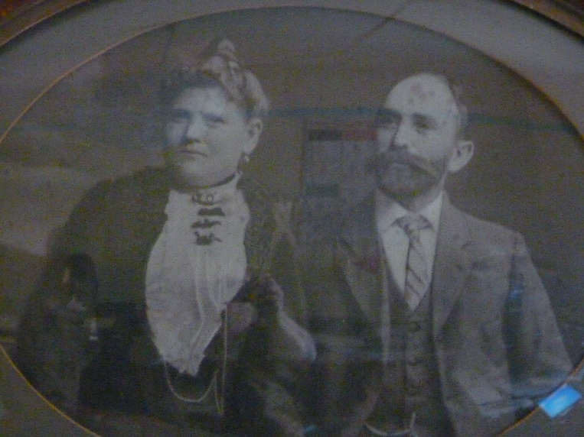
Aron-Moshe and Chana Grinblat
Parents of Bessie Zmood and Sophie Grinblat.
Date unknown, he died in 1919 in Melbourne or Ballarat

Maurice Zmood said "in Argentina there are Grinblats who are also Zmoods"
From that came his comment that all the families, Zmood, Grinblat and Komisauk, were descended from a common ancestor.

Tybel Komisaruk and Moshe Zmood had a sister who married a Grinblat.

I conducted considerable research into the Grinblat family.
I located the graves on Har Hazeitim of Harry Zmood’s wife Bessie’s grandfather Shmuel Grinblat, the father of five Grinblats, three of who settled in Australia and two (?) in Argentina.

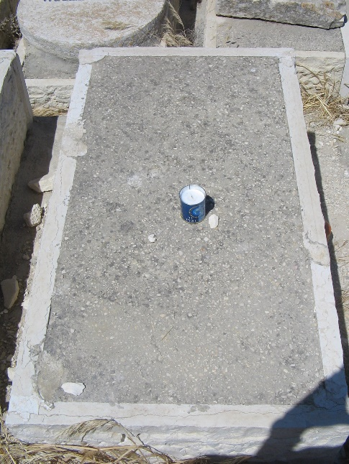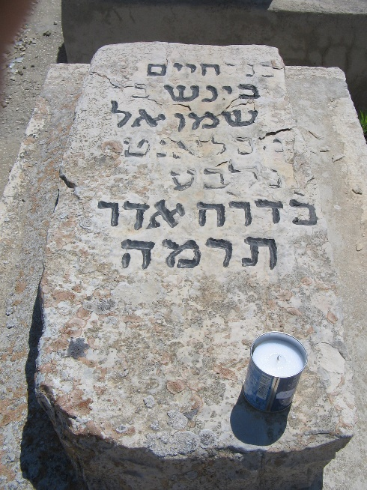
Shmuel Grinblat 1892 Har-Hazeitim Chaim-Benish Grinblat 1885
Jerusalem

Online data from an Argentinian site provided the name of Ana Zmud whose first husband was a Grinblat who died in 1892.
I believe that was Chaim-Benish who died in Jerusalem in 1885.

I also found records of grants in Jerusalem to the Grinblat family for various purposes, including assistance for a widow to return to Russia. I believe that was Chaim-Benish's wife Ana Zmud who may have returned to Russia or went straight to Argentine.
She remarried a Trainin by whom she had chidren.
Her son Aron-Moshe from her first married took the name Grinblat-Trainin.

Another case of inter-related marriages was the Pogorelsky family.
Menachem-Mendel Komisaruk married Beila-Reeva Pogorelsky, a daughter of Velvel Pogorelsky and Chaya-Sarah Gordon of colonies Kobilnya (Sladkovodnaya) and Nechaevka (Pennes).

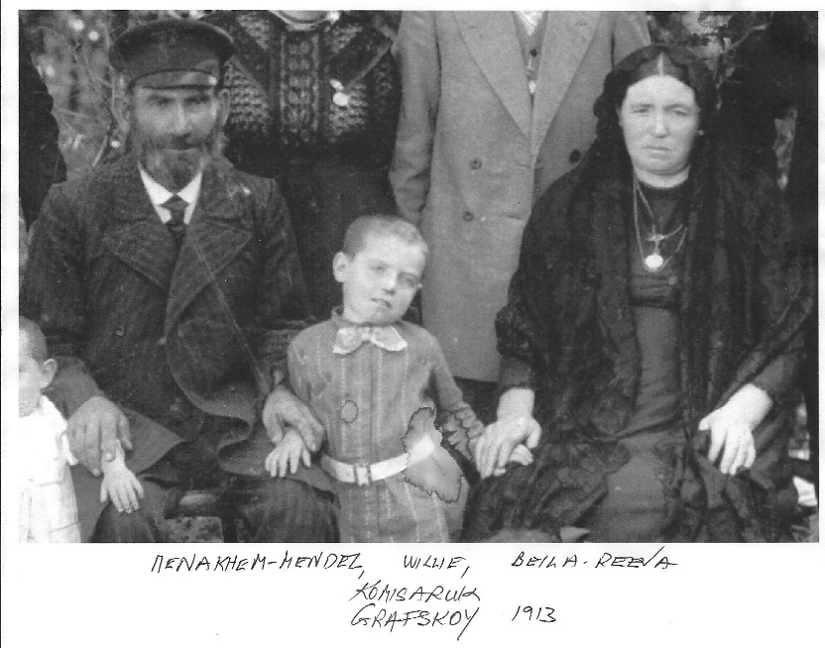

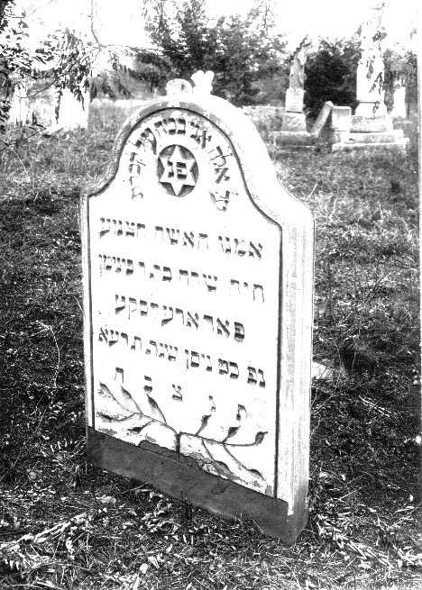
Chaya-Sarah Pogorelske, 1911, TsaraKonstantinovka, Ukraine.

Beila-Reeva is buried in a triple grave in Faulkner Cemetery in Melbourne, together with her brother Avraham-Sholem Pogorelske and his wife Simcha-Hinda Gordon who was also his cousin. She was a daughter of Moshe Gordon, a brother of Chaya-Sarah Pogorelsky.

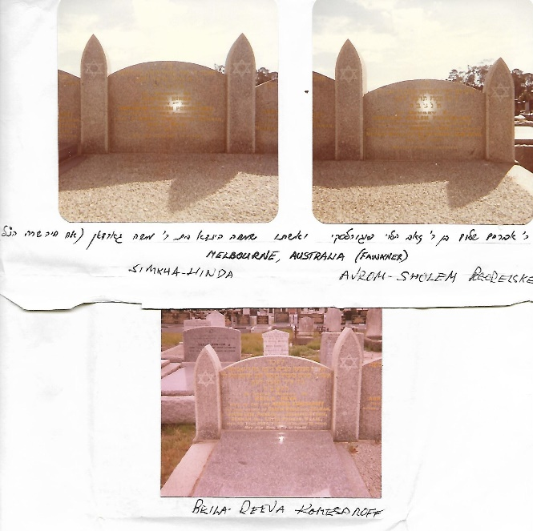

A son of Moshe Gordon Yitschak-Mendel married Chana, sister of Avraham-Sholom and Beila-Reeva.
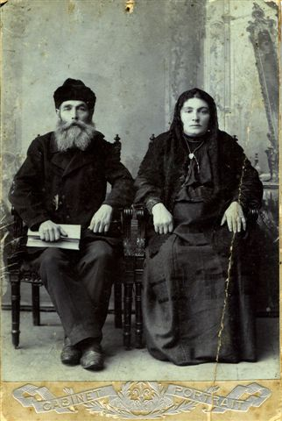
Yitschak-Mendel Gordon and Chana nee Pogorelsky, Nechaevka (Peness), Ukraine, before 1914.

Avraham-Sholom Pogorelske had a son Moshe-Zev (Masei) who married Sonya Batagol whose sister Fania married Shraga-Feibish Pogorelske.

The Batagol sisters were the daughters of Shraga-Feibish Batagol and Paya–Reeva Gordon, another child of Moshe Gordon and sister of Simcha-Hinda Pogorelske and Yitschak-Mendel Gordon.

Shraga-Feibish Batagol had a sister Leah who was the wife of Gerson Smorgan,the founder of the prestigious Smorgon family of Melbourne which also came from the same area as the above families.
Avraham-Shalom Pogerelske's son Benyomin married Esther Svidler, a sister of Bessie, the wife of Yaakov-Leib Komisaruk, son of Menachem-Mendel Komisaruk and Beila-Reeva Pogorelske. This Benyomin should not be confused with his uncle Benyomin Pogerelske, a brother of Avraham-Sholem, Chana Gordon, and Beila-Reeva Komisaruk.
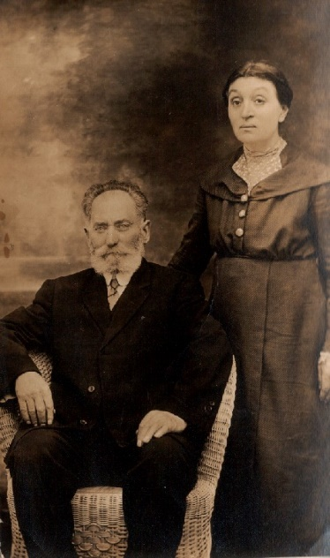 Benyomin son of Velvel Pogorelsky and Chaya-Sarah Gordon. Benyomin was brother of Beila-Reeva Komisaruk. He and his wife Fania remained in Russia.

Genetic testing would assist in determining relationships between these families.
But so far, while several Komisaruks have conducted Genetic testing, only one Zmood has done so and no Grinblats have.

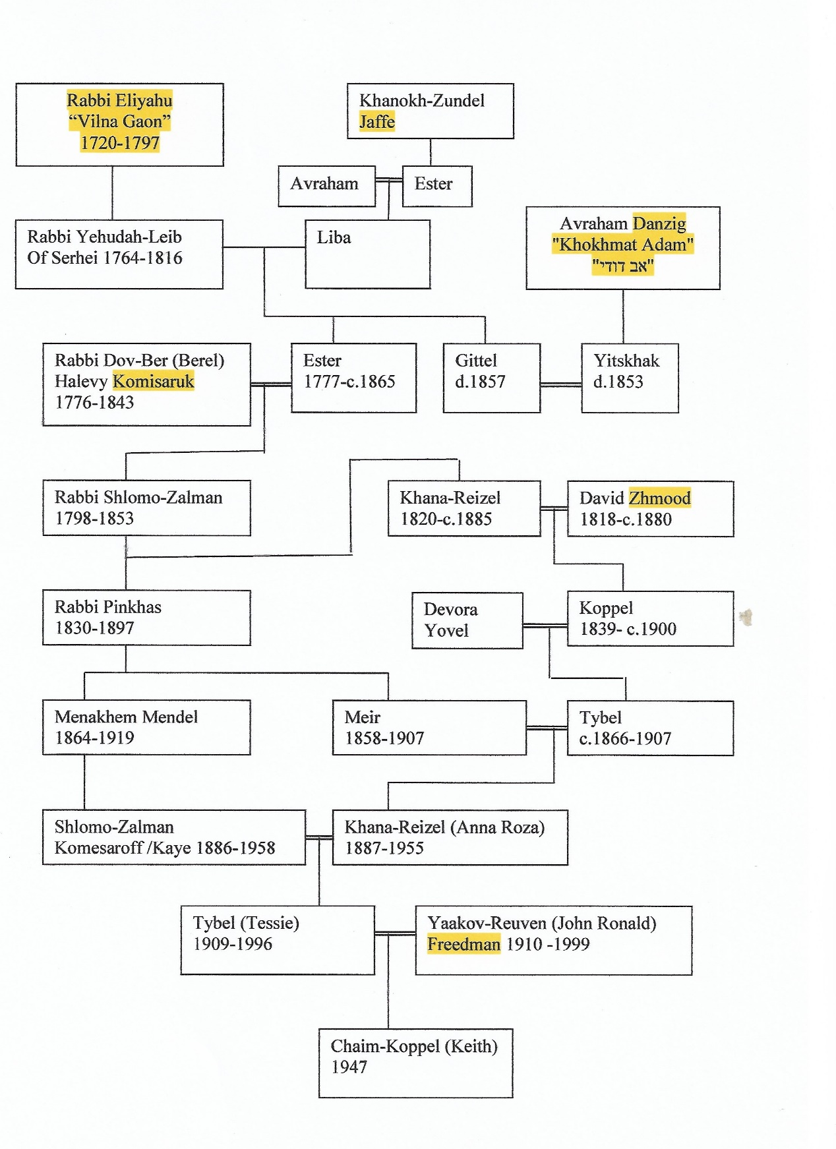
Amended 08/10/2020

Ancestry of Chana-Reizel Komesaroff Kaye
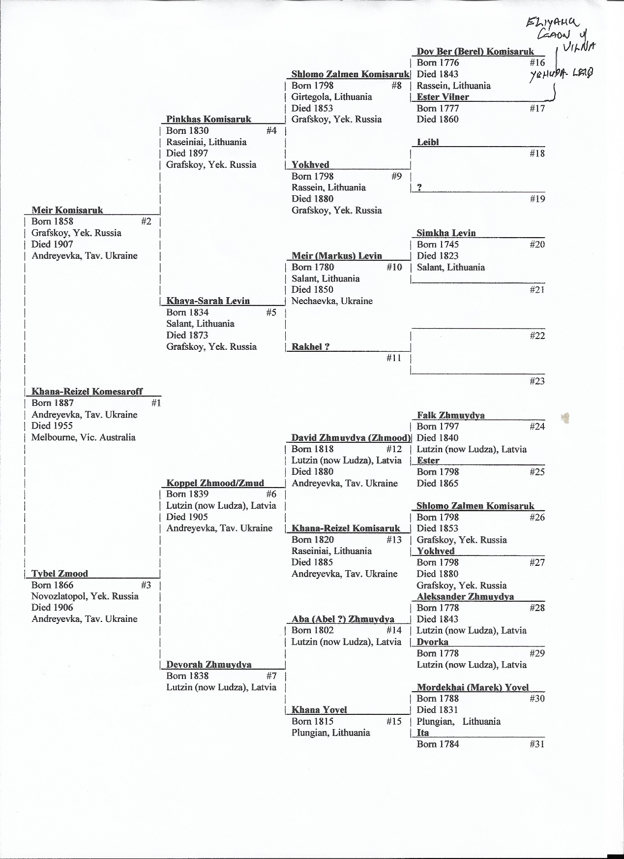

Ron Zmood the son of Maurice is of the opinion that the Grinblat family is not related to the Komisaruk family other than by the marriage of His grandfather Tzvi (Harry) and Harry’s sister Sophie to Grinblat siblings.
My mother Tessie Freedman called Morry “Meish” and abbreviation of the Lithuanian pronunciation of his Hebrew name Moshe.
“A Networked Community” Sue Silberberg, Melbourne University Press 2020. Page 84 Consanguinity.
“The Interlocking Melbourne Russians”, Chaim Freedman and Julie Ruth, Roots-Key Newsletter, Jewish Genealogical Society, Los Angeles, Spring 2005
“The First of Forty Families”, Tess Schwartz, Makor2001
https://kehilalinks.jewishgen.org/Colonies_of_Ukraine/memoirs_of_rokhel_luban.htm
https://kehilalinks.jewishgen.org/colonies_of_ukraine/articles/MelbourneRussians.htm Roots-Key Newsletter of the Jewish Genealogical Society of Los Angeles Spring 2005. Editor Nancy h Holden, The Interlocking Melbourne Russians by Chaim Freedman and Julie Ruth
Family tree of the Komisaruk family https://www.dropbox.com/s/0p1yzxkmii7s3dv/Komesaroff-Komisaruk%20family%2018022020%20%20Chaim%20Freedman%202020.docx?dl=0
Chaim (Keith) Freedman’s Hebrew name is Chaim-Kopel. He was named after his great-great grandfather Kopel Zmood, apparently the only descendant name after Kopel.
https://kehilalinks.jewishgen.org/Colonies_of_Ukraine/ Chaim Freedman’s books “Our Fathers’ Harvest” and its supplement. Melbourne 1982, 1990. Out of print. Sections appear on the above web site.
Michoel Ron received the material from Denis Krol.
The Bruser family in Grafskoy was not found by the archive researcher, possibly as it appeared with another in-law-related family, Gotlib.
The father’s of the wives of the family of David Zmood were missed.
The anomaly of such an age difference was pointed out by Mel Comisarow.
That name was preserved by a later generation, my daughter Avigayil-Chana Freedman, a great-granddaughter of Chana-Reizel Komesaroff/Kaye.
I met Chana-Reizel Lehrer at a cemetery for family tombstone consecration. Until then I did not know the name of her and my grandmother’s Zmood grandmother. I was told “Deveira”, the Lithuanian pronunciation of Dvora. Chana=Reizel told me that her daughter Doris was named after that Deveira. She also told me that her parents or grandparents told her about the family’s journey from Lithuania and Latvia to the colonies in the Ukraine “on covered wagons like in America when the pioneers traveled to the West”. Further information was that the family had suffered by the Napoleonic invasion in the North. Indeed there is such a record in the city Telsh (Telz), which neiboured on the Yovel hometown Plungyan. See Komisaruk family history regarding a similar difficult journey from Raseiniai in wagons,
The spelling of the surname Zmood was used in Australia, while the Russian records use Zmud, Zhmuydya, Zmudya.
Spelled Pogorelske in Melbourne.
See site https://kehilalinks.jewishgen.org/Colonies_of_Ukraine/colonies.html#location
William Kaye son of Shlomo-Zalman and Chana-Reizel Komesaroff, was told repeatedly by a member of the Smorgon family that the Smorgons and Komesaroffs were related. That relationship was a case of cousins of cousins through the Batagols and Pogorelskes but without a blood relationship to the Komesaroffs.
See research of Chaim Freedman http://eliyahusbranches.blogspot.com/2018/08/genetic-master-list-for-relatives-of.html
Ron Zmood the son of Maurice is of the opinion that the Grinblat family is not related to the Komisaruk family other than by the marriage of His grandfather Tzvi (Harry) and Harry’s sister Sophie to Grinblat siblings.

